TO LET OPEN STORAGE LAND

Blackwater Trading Estate
Maldon, Essex

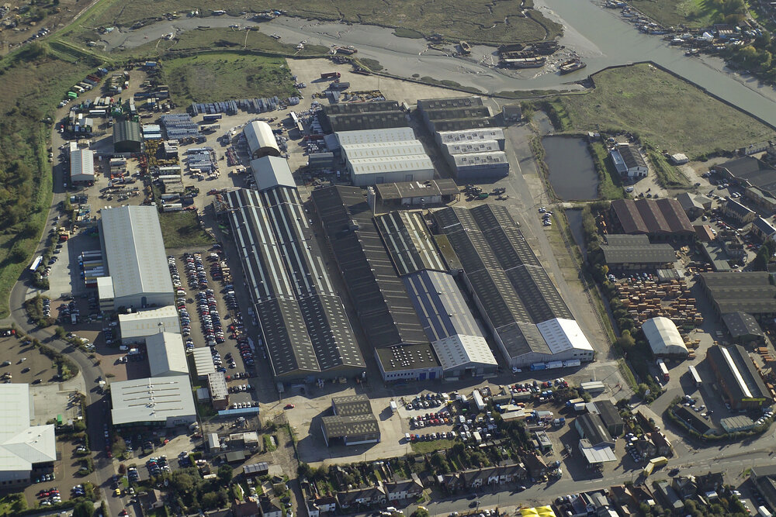

Key Highlights

- 0.85 3 Acres | - Concreted hard standing
- Rent from £2.50 psf

Viewing and further information

Viewings strictly by prior appointment with the Lettings Agent

Savills

Phil Dennis
pdennis@savills.com
01245 293216


IMPORTANT NOTICE

Maps are reproduced from the Ordnance Survey Map with the permission of the Controller of H.M. Stationery Office. © Crown copyright licence number 100022432 Savills (UK) Ltd, published for the purposes of identification only and although believed to be correct accuracy is not guaranteed.

Savills, their clients and any joint agents give notice that: 1. They are not authorised to make or give any representations or warranties in relation to the property either here or elsewhere, either on their own behalf or on behalf of their client or otherwise. They assume no responsibility for any statement that may be made in these particulars. These particulars do not form part of any offer or contract and must not be relied upon as statements or representations of fact. 2. Any areas, measurements or distances are approximate. The text, photographs and plans are for guidance only and are not necessarily comprehensive. It should not be assumed that the property has all necessary planning, building regulation or other consents and Savills have not tested any services, equipment or facilities. Purchasers must satisfy themselves by inspection or otherwise.

24.4.25

nits 9 & 10

